

Group 7

MS809: Enterprise Systems
Group 7: Data Dynamos
Total Word Count: 2051

Group Details

Student ID | Name | Email
24240124 | Pooja Prabhakar Manjarekar | P.Manjarekar1@universityofgalway.ie
24240627 | Akshata Anil Ghumatkar | A.Ghumatkar1@universityofgalway.ie
24238824 | Shubham Bhatnagar | s.bhatnagar2@universityofGalway.ie
24232193 | Devraj Raghuwanshi | D.Raghuwanshi1@universityofgalway.ie
24236930 | Amit Kumar | A.Kumar13@universityofgalway.ie

“In submitting this work we confirm that it is entirely our own. We acknowledge
that we may be invited to undertake an online interview if there is any concern in
relation to the integrity of our submission.”

Table of Contents
Group Details 2
Introduction 4
Determining critical success factors that were overlooked 4
Assessing common risks in ERP implementation 6
Identifying and analyzing contributing factors to the failure 8
Outlining the necessary steps to redeem the project 10
Detailing management approach for a successful outcome 12
References 13

Introduction
This report examines a case study involving the implementation of an ERP system within a major public sector organization in the UK. The project encountered significant challenges, ultimately resulting in its failure.

Determining critical success factors that were overlooked

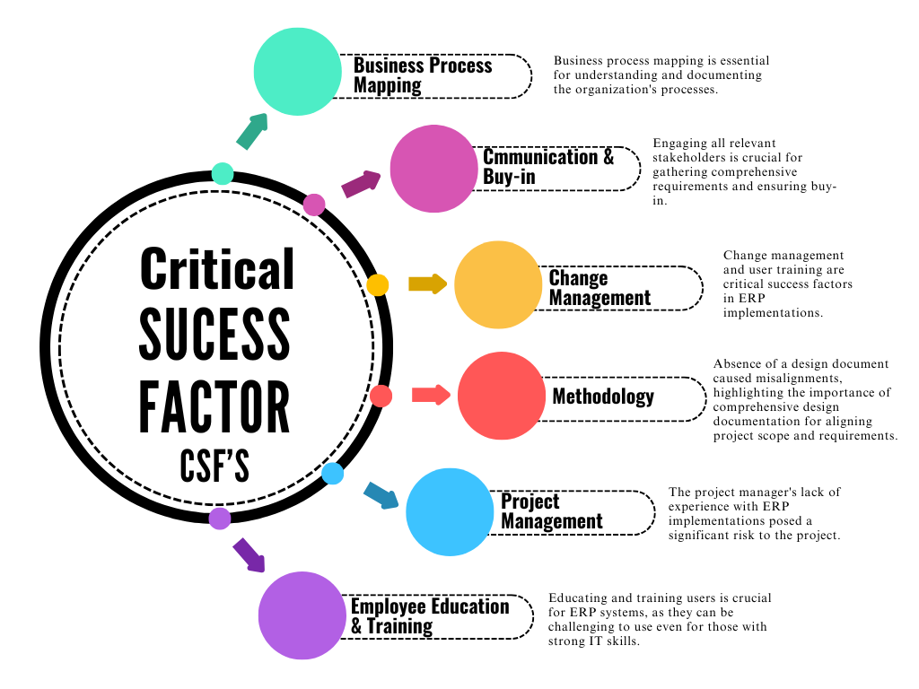
Figure 1: Critical Success Factor (CFS's)
Several critical success factors were overlooked in this ERP implementation.
Organization Business Process Mapping: The absence of representatives from the Birmingham office caused incomplete process mapping and the requirements were based on a "wish list" rather than a structured analysis of business needs, which negatively impacted on the project's success. [1]
Stakeholder Communication & Engagement (Buy-in): The Birmingham office, which had sole responsibility for parts of the business, was not represented on the project team. This absence of representation helped to generate dissatisfaction with the solution, even in areas where the system performed well. [2]
Change Management: The project did not emphasize change management or training of users.[3]

Project Management: Cross-functional collaboration was not good. The inexperience of the project manager with ERP implementations presented a significant threat to the project.[2]

Methodology: There was no formal project kick-off, and the project lacked a structured methodology. [1]

Employee Education & Training: The client's IT team had no prior ERP experience, and there was no plan to prepare the organization for the new system. [3]

Assessing common risks in ERP implementation

Risk categories
ERP implementation risks fall into five key categories: technical, schedule, operational, business, and organizational. Technical risks arise from the chosen hardware and software, which may experience performance, quality, reliability, integration challenges, or security vulnerabilities. Additionally, improper data migration and inadequate system testing can lead to failures. Schedule risks affect the project's ability to be completed on time. Lack of clear milestones, poor resource allocation, or dependency on third-party vendors can further delay the timeline. Operational risks stem from cost uncertainties, often due to scope creep where additional features are added during the project, leading to increased expenses. Inadequate user training and resistance to new workflows can also disrupt operations.
Business risks emerge from external factors beyond the project's control, such as economic shifts, legal regulations, market dynamics, skill shortages, and political influences. Poor alignment between ERP implementation and business goals can make it difficult to achieve expected ROI. Organizational risks involve internal challenges that may prevent project completion or hinder the realization of ROI, such as inadequate infrastructure, lack of skilled personnel, ineffective change management strategies, or lack of executive buy-in.
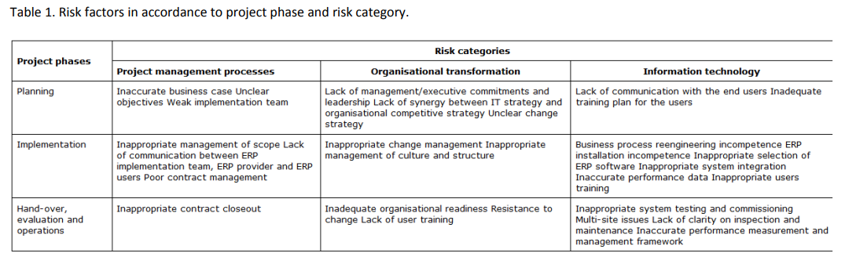
Figure 2: Risk Factors based on Risk Category and Project Phases ^{[6]}

Risk Mitigation Plan

Risk can be mitigated by following a structured process, as illustrated in the image below. The process begins with identifying and classifying risks, where potential threats are recognized and categorized based on their nature and impact. Next, the analysing risk phase involves evaluating the likelihood and consequences which help in prioritizing (using Risk Matrices). ^{[6]}

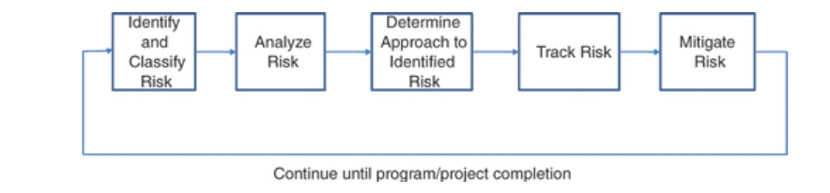
Figure 3: Risk Management Approach ^{[6]}
Once risks are analysed, the next step is to determine an approach to identified risks, where strategies such as avoidance, mitigation, transfer, or acceptance are considered to manage risks effectively. Following this, the tracking risk phase ensures continuous monitoring of identified risks, allowing teams to detect any changes in their severity or impact over time. The final step, mitigating risk, involves implementing corrective actions to reduce the probability or impact of risks on the project. This cycle continues iteratively until the program or project is completed, ensuring proactive risk management throughout its lifecycle. ^{[6]}

These risks can be mitigated to a certain extent by following a framework as provided in the diagram below.

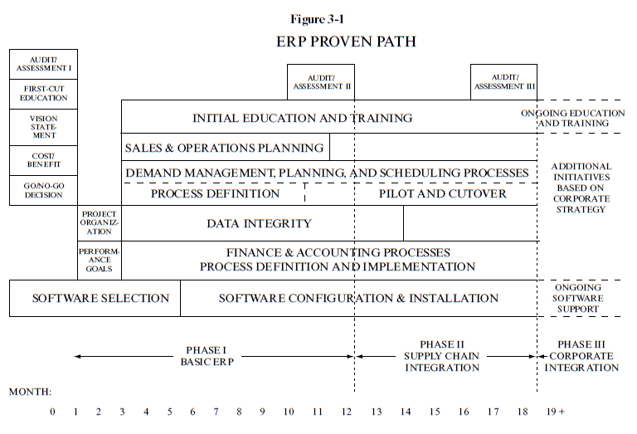
Figure 4: Proven path for ERP Implementation ^{[5]}

Identifying and analyzing contributing factors to the failure
Multiple crucial variables contributed to the ERP installation project's failure. Initially, inadequate requirement collection resulted in ambiguous and impractical specifications. In focusing on software functionality instead of business processes, Consultancy A's functional specification fell short of capturing the actual demands of the customer. To make matters worse, the Birmingham office was left out of the requirement collection process.

A fixed-price contract based on an insufficient specification limited flexibility for revisions, which was the second problem in the procurement and contract structure. Consulting B, which used a conventional implementation process, was under pressure to fulfill strict and unachievable objectives.

Stakeholder disputes made development much more difficult, especially between the consultants. Delays and inefficiencies were caused by interpersonal disputes and poor communication among team members. A clear design document and inadequate project control also led to scope ambiguity and a misalignment with business requirements.

Major functional gaps were only found during acceptance testing, a year later, as a result of inadequate testing and a failure to detect important issues early. An unstable solution was also the consequence of inadequate data migration techniques and an inability to handle intricate integration requirements. The project's failure was eventually caused by these problems, which were made worse by the ERP system's limits and a lack of experience with important aspects like cash accounting.

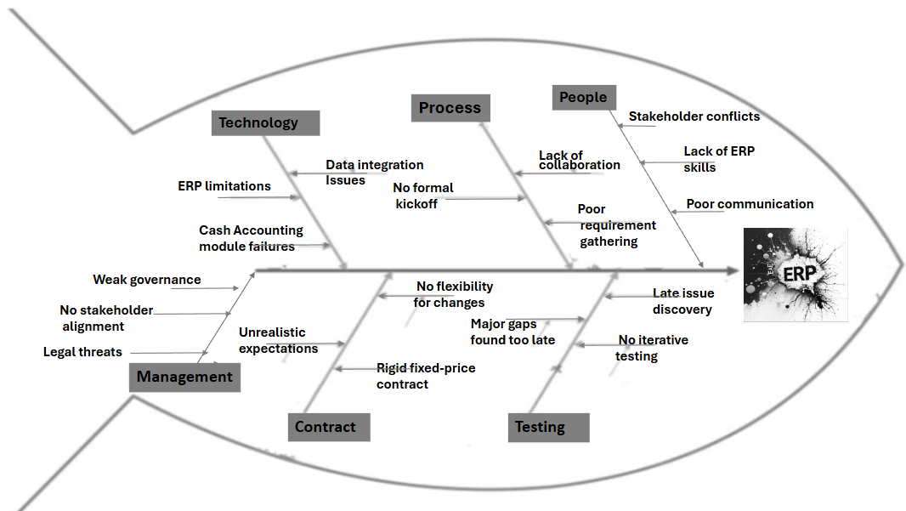
Figure 5: Root Causes of ERP Implementation Failure
The 1999 Hershey's ERP deployment is among the most prominent instances of ERP failure brought on by inadequate testing and subpar data. The company skipped extensive testing in favor of a hasty go-live, which resulted in problems like improper order processing and shipment delays. Furthermore, erroneous data was transferred to the new ERP as a result of subpar data migration from legacy systems. This combination led to $100 million in lost sales, strained customer relations, and major operational interruptions. This case is frequently used to highlight how important it is for ERP implementations to have clean data and thorough testing. ^{[7]}

Outlining the necessary steps to redeem the project

The following steps should be taken in the current scenario to redeem the project -
- Conduct a holistic Project Review – Thoroughly reviewing each aspect of the project to identify all gaps, issues and misalignment with reviewing of the functional specifications, designs and project progress by engaging independent third party or a senior expert from Consultancy will give clear understanding of the failures and listing the reasons for it.
- Revisit and Rebase Requirements – Facilitating workshops with key stakeholders with key stakeholders to revisit the functional specification to separate conflicting or unrealistic “wish list” items from core business needs will give a revised and realistic set of requirements that align with the ERP system’s capabilities and the client’s business processes.
- Form a Clear Design Document – Ensuring revised requirements are signed off by all parties and using it as the basis for design document will serve as foundation with clear scope and design for the further project phases.
- Bridge functional gaps with vendor support – Request dedicated support from the vendor, specifically experienced consultants will help in resolving technical issues and domain expertise to address the functional gaps, especially the Cash Accounting module and data integration issues. Hence, shall result in a stable and functional solution while fulfilling client’s key requirements.
- Enhance Testing and User Acceptance – A thoroughly tested solution for the deployment with end user acceptance could be achieved by including end-users from all business units in the testing process to meet solution requirements.
- Implement Change Management and Training – Develop and executing a change management plan through communication, training sessions for all users and support after the new system implementation will result in seamless transition of the new system while reinforcing confidence in user on their capabilities of using it effecting.

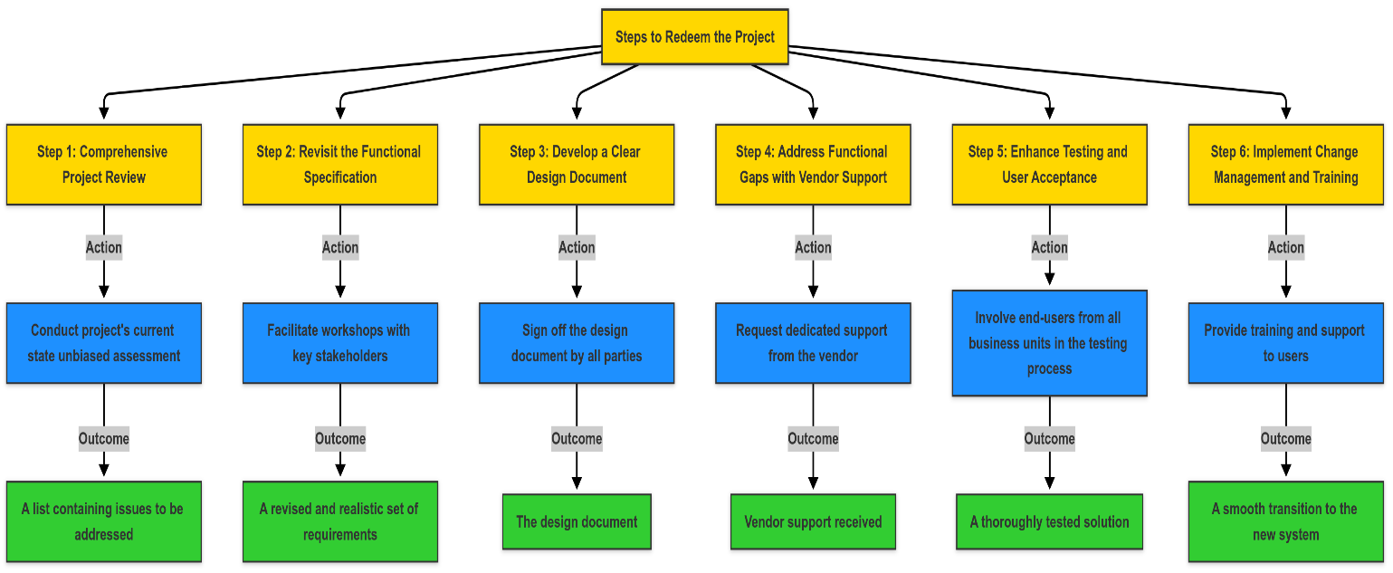

Detailing management approach for a successful outcome
ERP implementation projects in public sector organizations frequently face challenges that can lead to costly failures. Research by Deloitte (2014) indicates that approximately 55-75% of ERP projects fail to achieve their intended objectives, primarily due to poor project management, unclear scope, insufficient testing, and inadequate change management practices. The recent case of Birmingham City Council highlights the severe repercussions of such failures, where unresolved issues in their ERP implementation significantly disrupted financial management, eventually contributing to financial instability (The Register, 2021).
To effectively recover from the current ERP failure, our management approach focuses on systematically addressing each of these critical areas.
1. Reassessment and Stabilization:
Initially, we must pause further deployment activities and perform a thorough project audit, ideally with independent experts, to accurately identify and diagnose the root causes of failure. This audit will pinpoint critical issues such as incomplete solution design, inadequate data migration, or technical bugs. For example, Birmingham City Council’s ERP failure demonstrated the importance of fully resolving design issues before progressing (The Register, 2021). Similarly, during National Grid's ERP stabilization, considerable resources were devoted to maintaining essential business processes like payroll and billing, highlighting the need for temporary measures to keep core operations running smoothly (Panorama Consulting, n.d.). Applying these lessons ensures we identify and resolve fundamental problems, enabling the project to regain stability and move forward effectively.

2. Effective Governance and Leadership:
Establishing a robust governance framework with clearly defined roles and responsibilities is crucial. A dedicated steering committee involving top management, departmental leaders, and key stakeholders should oversee the ERP recovery. The case of Nestle highlights how effective governance with active senior leadership can help manage complexity and maintain project control, thus avoiding costly delays and ensuring alignment across departments (Davenport, 1998). Additionally, incorporating independent oversight, such as internal auditors or external experts, will ensure transparency and accountability. By empowering these oversight bodies, we mitigate risks of miscommunication and overlooked critical issues, enhancing the project's likelihood of success (Panorama Consulting, n.d.).

3. Realistic Scope and Agile Planning:
A manageable and clearly defined project scope, along with realistic timelines, is vital. We should focus on essential functionalities first, utilizing MoSCoW prioritization to differentiate between mandatory features and "nice-to-have" options. Hershey's ERP implementation failed due to an overly ambitious scope and unrealistic timelines, highlighting the need for incremental, phased deployments (Panorama Consulting, n.d.). A phased agile implementation, as demonstrated by Rolls-Royce, allows incremental delivery, early issue detection, and flexibility to adapt based on real-world feedback (McKinsey & Co., n.d.). By embracing this iterative approach, we can significantly reduce risks and deliver incremental wins that build stakeholder confidence.

4. Comprehensive Change Management and Continuous Improvement:
Finally, robust change management strategies must support the implementation to ensure smooth user transition and adoption. A dedicated change management team should develop extensive role-specific training programs, ongoing user support, and a clear communication plan to keep stakeholders engaged. For instance, the University of Nottingham effectively mitigated resistance and increased user adoption through targeted training initiatives (IEEE Software, n.d.). Additionally, thorough testing, including realistic scenario-based user acceptance tests, ensures the system meets organizational needs before full deployment. The importance of rigorous testing was demonstrated by National Grid, whose inadequate initial testing resulted in severe operational disruptions (Panorama Consulting, n.d.). Post-implementation reviews and continuous monitoring through clearly defined KPIs, as seen in the City of Toronto’s ERP stabilization efforts, will support ongoing system optimization and long-term value realization (McKinsey & Co., n.d.).

Implementing these four core strategies comprehensively addresses the critical areas necessary to recover and ensure the successful outcome of the ERP project. By learning from industry examples and rigorously applying these approaches, we significantly improve our chances of turning the troubled ERP implementation into a stable, beneficial, and sustainable solution for the organization.

References

- Umble, E.J., Haft, R.R. and Umble, M.M. (2003) ‘Enterprise resource planning: Implementation procedures and critical success factors’, European Journal of Operational Research, 146(2), pp. 241–257. doi:10.1016/s0377-2217(02)00547-7.
- Al‐Mashari, M. and Al‐Mudimigh, A. (2003) ‘ERP implementation: Lessons from a case study’, Information Technology &amp; People, 16(1), pp. 21–33. doi:10.1108/09593840310463005.
- Stone, A. R., & Zhang, X. (2021). Understanding success factors for ERP implementation: An integration of literature and experience. Issues in Information Systems, 22(2), 146–156. https://doi.org/10.48009/2_iis_2021_150-161
- (No date a) (PDF) the impact of critical success factors across the stages of enterprise resource planning implementations. Available at: https://www.researchgate.net/publication/232641256_The_Impact_of_Critical_Success_Factors_across_the_Stages_of_Enterprise_Resource_Planning_Implementations (Accessed: 22 March 2025).
- Kremzar, M.H., Krezmar, M.K. and Wallace, Thomas F. (2002) ERP: Making it happen: The implementers’ guide to success with enterprise resource planning. Wiley.
- Risk management in enterprise resource planning ... Available at: https://publications.aston.ac.uk/id/eprint/19937/1/Risk_management_in_enterprise_resource_planning_implementation.pdf (Accessed: 27 March 2025).
- Kopis USA (n.d.) ERP implementation failure: Hershey Foods case study. Available at: ERP_Implementation_Failure_Hershey_Foods.pdf

